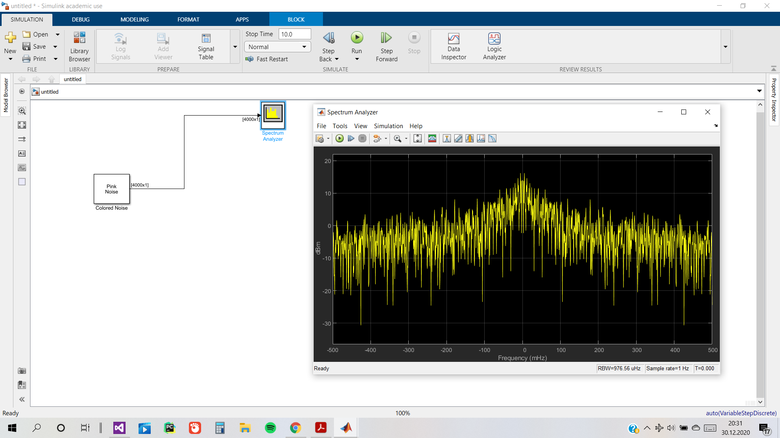

This is the spectrum of the Pink Noise.

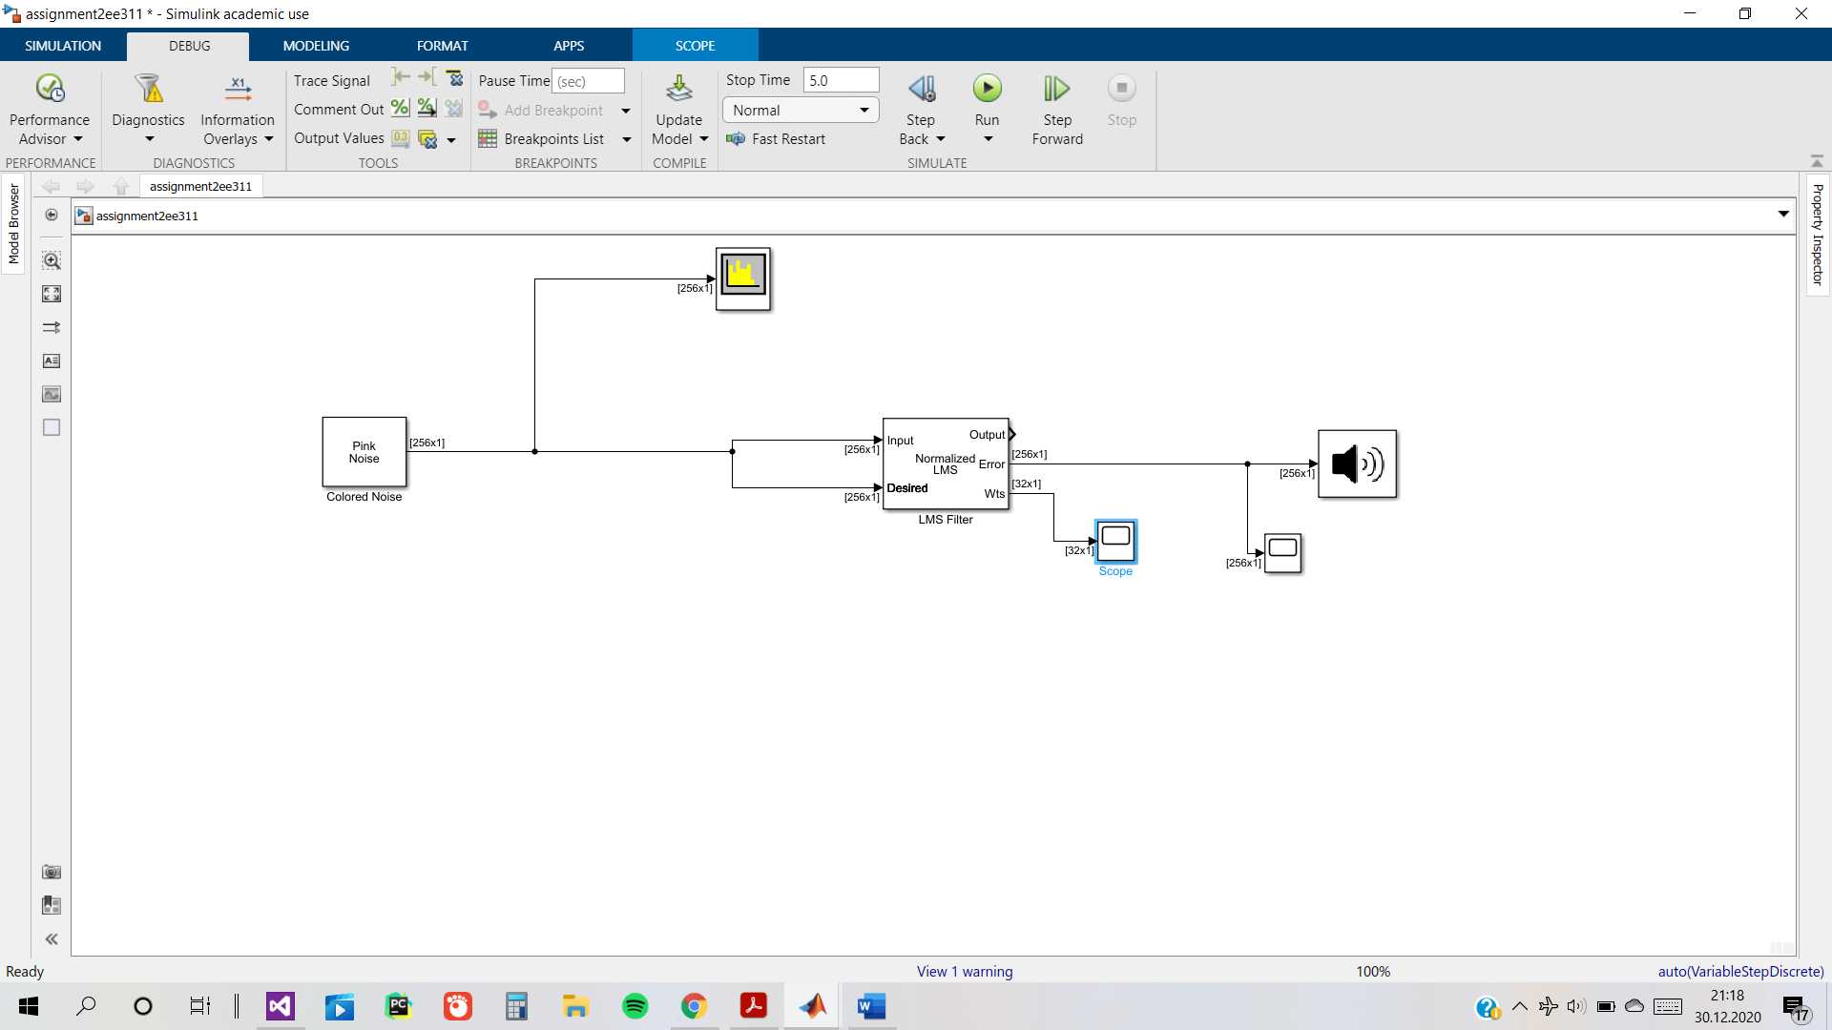

Simulink for anti-noise schematic on just the Pink Noise.

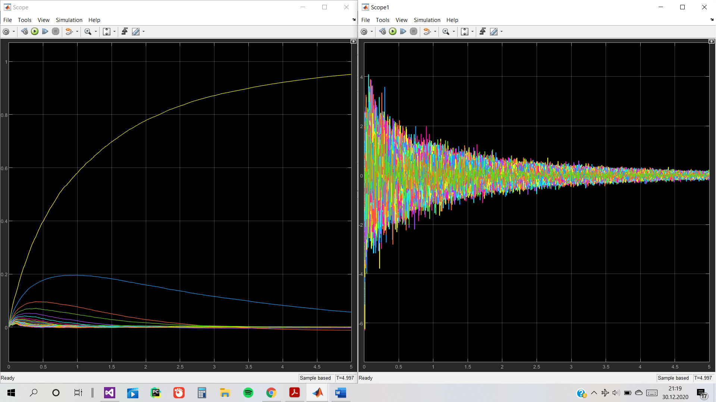Weights for noise cancellation and scope view of noise diminishing.

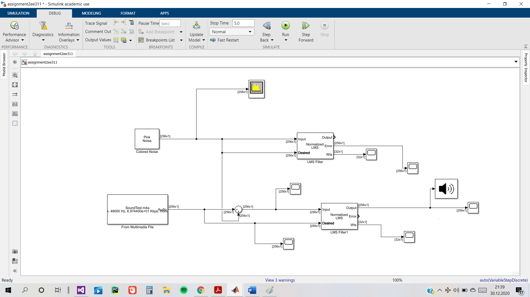Schematic of noise-cancellation when noise and original sound are added together.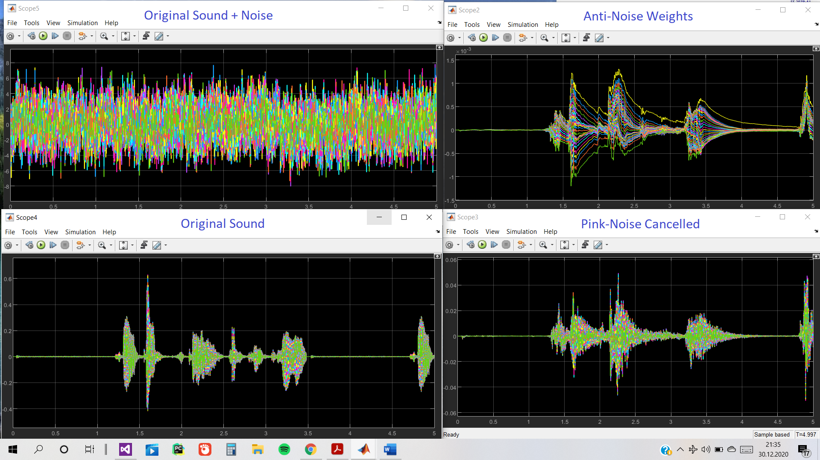

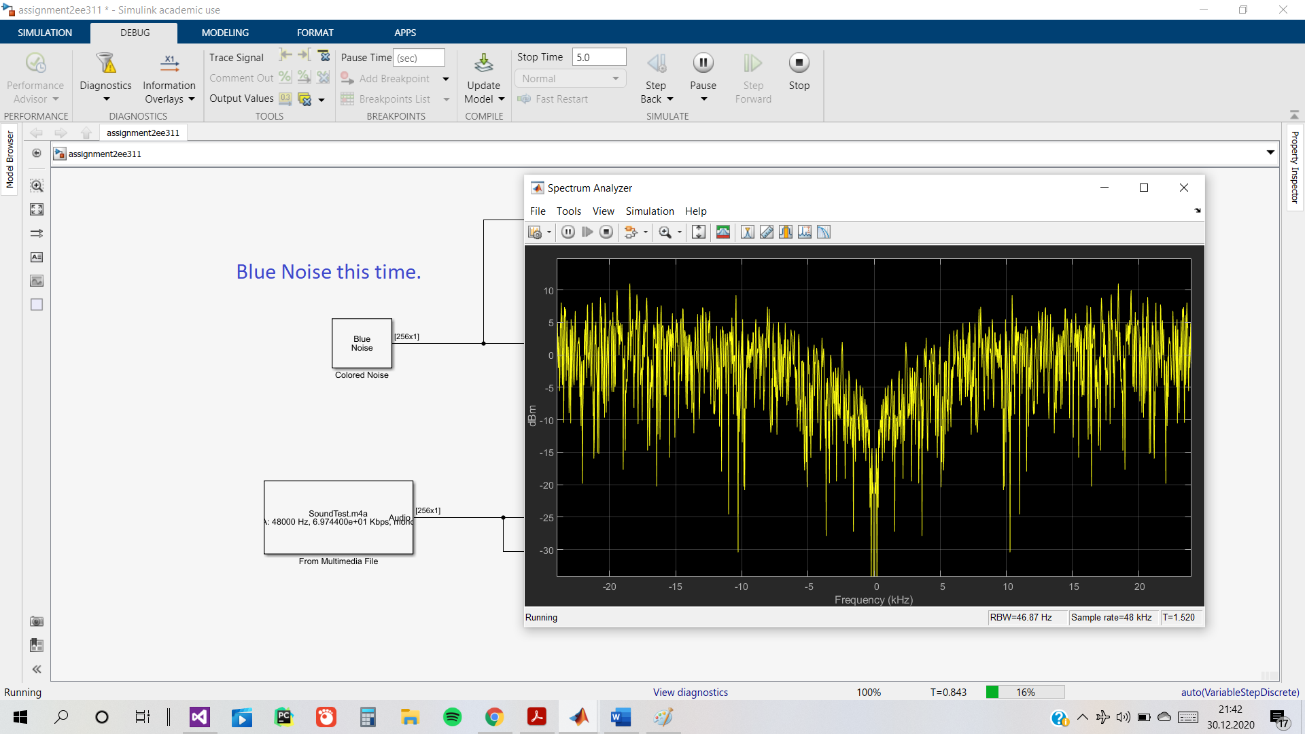

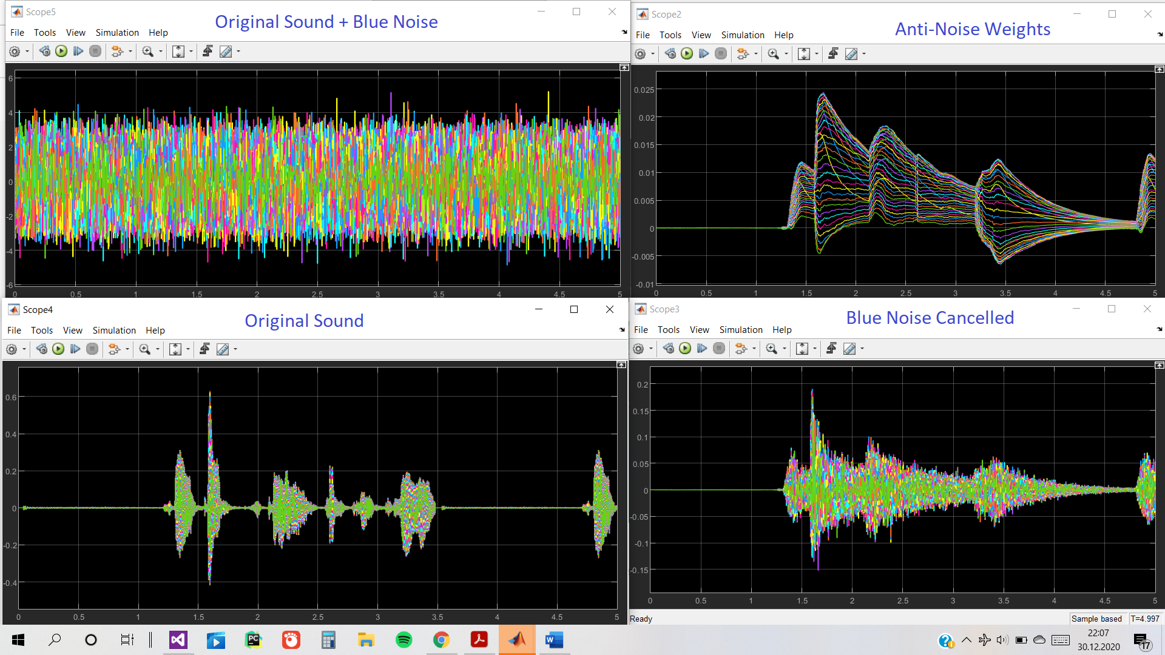

Relative to Pink Noise, noise-cancellation on Blue Noise is a bit less successful. Noise cancellation on Pink Noise resulted in sharper resulting signal.